SIMATS ENGINEERING
ASSESSMENT TOOL 1
Experiments

COURSE NAME: OBJECT ORIENTED ANALYSIS AND DESIGN
COURSE CODE: CSA11

COURSE OUTCOME COVERED

CO3: Analyze system requirements using object-oriented techniques to identify classes, attributes, and relationships and develop use case models. (BL4)

Assessment Tool Weightage: 40%

Code of Conduct:
I Nithishkumaran M 192320037 (Name / Reg No) certify that this submission is my original work and that I have adhered to the guidelines specified for this assessment.
I understand that any violation of academic integrity rules will result in disciplinary action.
Signature of the student:
Nithishkumaran M

1. Book Bank Management System
Design and model a Book Bank Management System using UML to automate student verification, book allocation, and issue management. The system shall allow the Book Bank Administrator to capture and submit student credentials to the Central Verification System for validating student eligibility. Based on successful verification, the system shall generate an approval status and communicate it to the Book Bank Office. The office shall retrieve the approved student's requirements, verify book availability, and issue the requested books. The system shall maintain student, book inventory, issue, and return information with appropriate relationships among the entities. Analyze the functional requirements and develop suitable UML models representing the structural and behavioral aspects of the system.

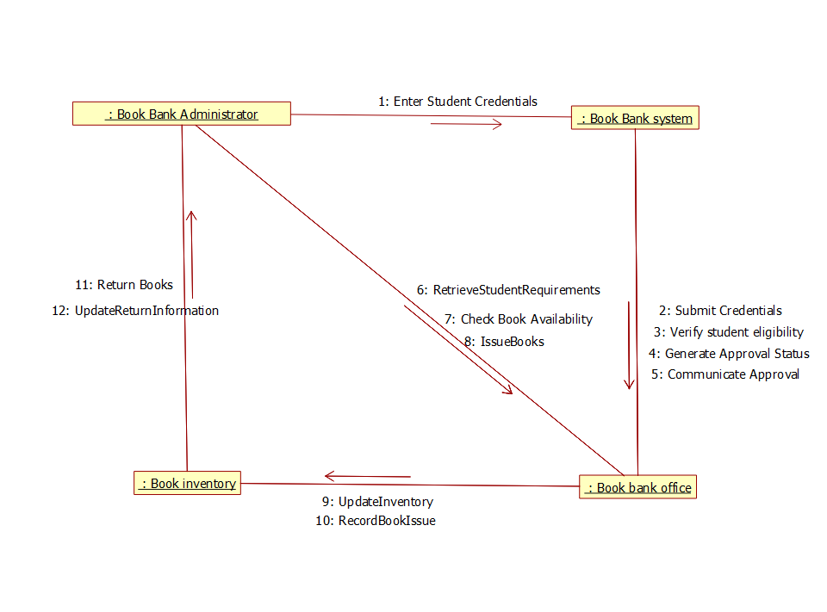

RUBRICS FOR CALCULATION:

Experiments

Criteria | Weightage | Level 4 – Exemplary | Level 3 – Proficient | Level 2 – Developing | Level 1 – Beginning
Understanding of Concepts | 25 | Demonstrates thorough understanding and effectively integrates multiple concepts/technologies | Good understanding with proper integration of most concepts | Basic understanding; limited or partial integration | Poor understanding; unable to integrate concepts
Experimental Design | 30 | Well-planned, systematic implementation with optimal solution | Correct implementation with minor issues | Basic implementation with errors or inefficiencies | Incorrect or incomplete implementation
Use of Tools | 20 | Effective and advanced use of tools/technologies with proper configuration | Appropriate use of tools with correct execution | Limited or inconsistent use of tools | Incorrect or minimal use of tools
Analysis of Results | 15 | Insightful analysis with accurate interpretation and validation of results | Good analysis with reasonable interpretation | Basic analysis with limited insights | Poor or incorrect analysis of results
Documentation | 10 | Clear, well-structured documentation with diagrams, code, and results | Organized documentation with necessary details | Basic documentation with missing details | Poor or incomplete documentation

